

UNIVERSITY OF MINING AND GEOLOGY “Engineering” LTD
Laboratory "Lighting" www.light-bg.eu
tel. (02) 8060 302, e-mail: candela@mail.bg

Measurement report number 2017-069/20.02.2017

testing samples of products

Model number or type, referring to the manufacturer: LUPO
Company identification: “ISS” Ltd. 6, Gurko street, Vratsa, Bulgaria
Applicant testing: “ISS” Ltd. 6, Gurko street, Vratsa, Bulgaria
Type of test: control measurements

Metrological traceability:
- LMT Photometer B520, ID 04B4021 with photometric head P30SC0 ID 04B4022, calibration certificate of the LMT Lichtmesstechnik GMBH Berlin №04B402/28.05.2014;
- luxmeter PU 550, ID 263621/2586, calibration certificate of the METRA BLANSKO a.s.№2887/2012, 19.12.2012;
- luxmeter KYORITSU 5202, ID K0017929, calibration certificate of the National Centre of Metrology 181-ОИ/15.12.2012;
- luminance-meter L 1003 of angular field 1º, producer “LMT” Germany, ID 0686191, calibration certificate of the National Centre of Metrology 130-ОИ/20.12.2010;
- Ulbricht photometer with diameter 2м;
- Automated goniophotometer.
- Power Meter HM8115-2 ID 015447345, calibration certificate of the National Centre of Metrology 148-EEИ/14.12.2012;
- Digital thermometer with temperature sensor DS18B20 ID 0000011697CDH, calibration certificate of the National Centre of Metrology 268-TИ/14.11.2012;
- Ampermeter Д5101 ID 737/1990, calibration certificate of ‘ЛК УНИСИСТ’ Ltd №733/21.11.2012;
- MEGER UT512 ID 1111074682, calibration certificate of ‘ЛК УНИСИСТ’ Ltd №732/21.11.2012;
- Laser rangefinder DLE-40
- spectroradiometer МК350 ID HS0313220158, test source МК002, calibration certificate of UPRtek lab № А012001 / 2013/7/5
Technical specifications of documentation:
LED Luminaire LUPO – 2 pcs
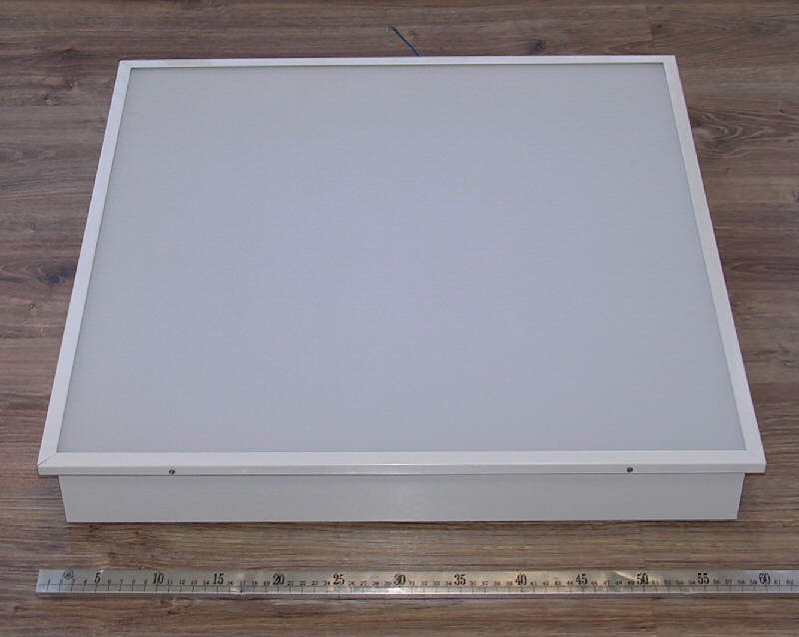
Luminaire
TEST REPORT 2017-069-20.02.2017 | page 1 | all pages 4

TEST REPORT 2017-069-20.02.2017 | page 2 | all pages 4
Results of the test of luminarie – Var 1 & 2
Operating voltage | AC 230 V | 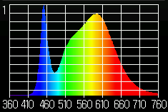  Spectrum of light  Koef. puls.= 41.7%
Operating Current | AC 0.144 A
Wattage including ballast (watts) | 30,52 W
Power factor | 0.94
color temperature | 4086 K
Color rendering index CRI | 80
color coordinates CIE 1931 | x=0.3773, y=0.3768
color coordinates CIE 1976 | u’=0.2230, v’=0.5011
Luminous flux emitted by a luminaire | 4308 lm
Light output of the luminaire | 141,3 lm /W
Luminous flux emitted by a luminaire Var2 | 4283 lm
Light output of the luminaire Var2 | 140,9 lm /W
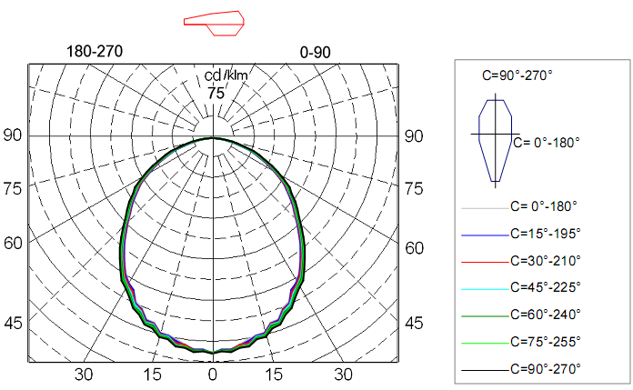
Luminaire light distribution of polar coordinates in the conditional flux 1000lm

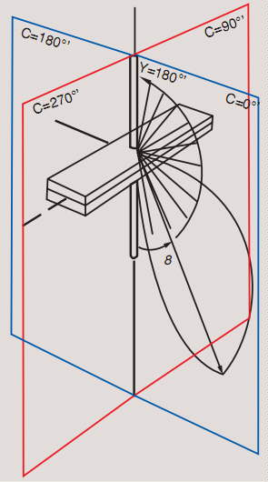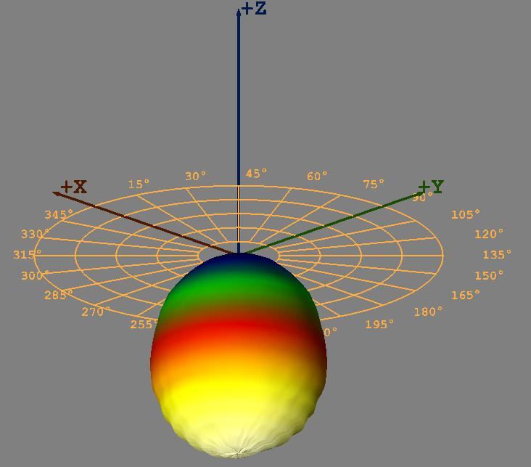
Luminaire light distribution of the 3D

TEST REPORT 2017-069-20.02.2017 | page 3 | all pages 4

Light distribution of luminaries are in tabular form
for conditional luminous flux 1000lm:
gm/C 0 15 30 45 60 75 90 105 120 135 150 165 180
0.0 397 398 397 397 398 398 398 398 398 397 397 398 397
2.5 392 392 394 394 393 394 395 394 393 394 394 392 392
5.0 392 393 394 395 394 397 398 397 394 395 394 393 392
7.5 385 387 386 389 389 390 391 390 389 389 386 387 385
10.0 379 382 385 389 390 390 391 390 390 389 385 382 379
12.5 373 375 376 377 379 380 381 380 379 377 376 375 373
15.0 373 374 375 377 378 380 381 380 378 377 375 374 373
17.5 358 360 360 362 364 367 369 367 364 362 360 360 358
20.0 357 359 361 363 365 366 367 366 365 363 361 359 357
22.5 340 343 344 346 349 352 354 352 349 346 344 343 340
25.0 334 337 339 340 344 345 347 345 344 340 339 337 334
27.5 316 317 320 324 328 330 332 330 328 324 320 317 316
30.0 309 310 312 315 317 319 321 319 317 315 312 310 309
32.5 298 299 302 305 307 310 312 310 307 305 302 299 298
35.0 282 284 286 289 291 294 296 294 291 289 286 284 282
37.5 266 269 271 275 277 280 281 280 277 275 271 269 266
40.0 252 254 256 259 260 263 266 263 260 259 256 254 252
42.5 235 237 239 242 244 247 249 247 244 242 239 237 235
45.0 220 222 224 227 229 232 233 232 229 227 224 222 220
47.5 205 207 208 211 213 215 218 215 213 211 208 207 205
50.0 194 194 197 199 201 204 206 204 201 199 197 194 194
52.5 180 182 185 187 189 192 193 192 189 187 185 182 180
55.0 167 168 170 173 175 178 179 178 175 173 170 168 167
57.5 156 157 160 162 165 167 169 167 165 162 160 157 156
60.0 138 140 143 145 148 150 152 150 148 145 143 140 138
62.5 124 125 128 130 132 135 137 135 132 130 128 125 124
65.0 109 111 113 115 118 120 122 120 118 115 113 111 109
67.5 93 95 97 99 101 104 106 104 101 99 97 95 93
70.0 81 82 84 86 88 90 93 90 88 86 84 82 81
72.5 70 71 72 74 76 78 80 78 76 74 72 71 70
75.0 52 53 54 56 58 60 62 60 58 56 54 53 52
77.5 40 41 42 43 45 47 48 47 45 43 42 41 40
80.0 30 31 32 33 35 36 38 36 35 33 32 31 30
82.5 19 20 20 22 23 24 26 24 23 22 20 20 19
85.0 10 11 11 12 13 15 16 15 13 12 11 11 10
87.5 2 3 3 4 5 6 7 6 5 4 3 3 2
90.0 1 1 1 1 3 3 4 3 3 1 1 1 1
92.5 1 1 1 1 1 1 1 1 1 1 1 1 1
95.0 1 1 1 1 1 1 1 1 1 1 1 1 1
Changing the light flux

TEST REPORT 2017-069-20.02.2017 | page 4 | all pages4

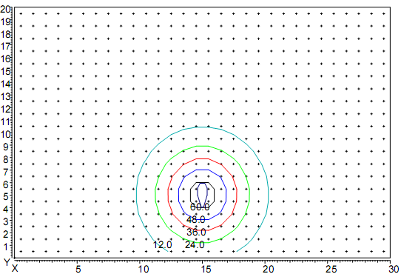

Distribution of illumination in height hanging lamp 5m
Coordinates of the luminaire X=15m, Y=5m.

Applications:
Files with the EULUMDAT format. Light distribution is captured in γ-С planes with step 2.5^{о} in plane γ (от 0 ^{о} - 95 ^{о}) и 5^{о} in plane С (от 0 ^{о} - 360 ^{о}) accordance with EN 13032-1 p 4.2.3.
Files with the measured values
- 2017-069.ldt (Var-1 ),
- 2017-069-1.ldt (Var-2),

Test results relate only to test samples.

Sofia 20.02.2017
Manager of Laboratory "Lighting":

/assoc. prof. d-r. Krasimir Velinov/

Manager:

/ prof. d-r. L. Totev/

