

UNIVERSITY OF MINING AND GEOLOGY “Engineering” LTD
Laboratory "Lighting" www.light-bg.eu
tel. (02) 8060 302, e-mail: candela@mail.bg

Measurement report number 2017-030/27.01.2017

testing samples of products

Model number or type, referring to the manufacturer: LED luminaire EMILI 48
Company identification: “Security Smart Systems “Ltd.
Applicant testing: “Security Smart Systems “Ltd. 6 Gourko str. Vratza
Type of test: control measurements

Metrological traceability:
- LMT Photometer B520, ID 04B4021 with photometric head P30SC0 ID 04B4022, calibration certificate of the LMT Lichtmesstechnik GMBH Berlin №04B402/28.05.2014;
- luxmeter PU 550, ID 263621/2586, calibration certificate of the METRA BLANSKO a.s.№2887/2012, 19.12.2012;
- luxmeter KYORITSU 5202, ID K0017929, calibration certificate of the National Centre of Metrology 181-ОИ/15.12.2012;
- luminance-meter L 1003 of angular field 1º, producer “LMT” Germany, ID 0686191, calibration certificate of the National Centre of Metrology №182-ОИ/15.12.2012;
- Ulbricht photometer with diameter 2м;
- Automated goniophotometer.
- Power Meter HM8115-2 ID 015447345, calibration certificate of the National Centre of Metrology 148-EEИ/14.12.2012;
- Digital thermometer with temperature sensor DS18B20 ID 0000011697CDH, calibration certificate of the National Centre of Metrology 268-TИ/14.11.2012;
- Ampermeter Д5101 ID 737/1990, calibration certificate of ‘ЛК УНИСИСТ’ Ltd №733/21.11.2012;
- MEGER UT512 ID 1111074682, calibration certificate of ‘ЛК УНИСИСТ’ Ltd №732/21.11.2012;
- Laser rangefinder DLE-40
- spectroradiometer МК350 ID HS0313220158, test source МК002, calibration certificate of UPRtek lab № А012001 / 2013/7/5
Technical specifications of documentation: LED luminaire EMILI 48
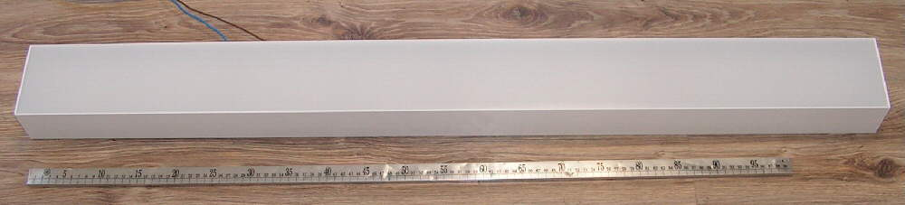
Luminaire

TEST REPORT 2017-030-27.01.2017 | page 1 | all pages 4

TEST REPORT 2017-030-27.01.2017 | page 2 | all pages 4

Results of test
Operating voltage | AC 230 V | 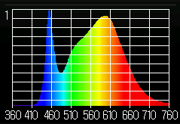  Spectrum of light  Kpuls.= 8.4 %
Operating Current | AC 0.226 A
Wattage including ballast (watts) | 50.8 W
Power factor | 0.97
color temperature | 4070 K
Color rendering index CRI | 82
color coordinates CIE 1931 | x=0.3779, y=0.3767
color coordinates CIE 1976 | u’=0.2234, v’=0.5012
Luminous flux emitted by a luminaire | 5787 lm
Light output of the luminaire | 114lm /W

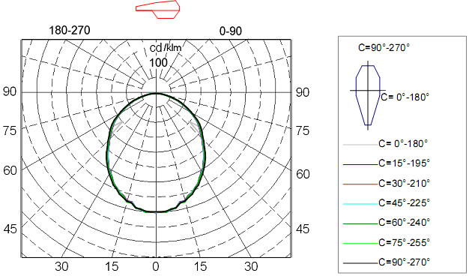
Luminaire light distribution of polar coordinates in the conditional flux 1000lm
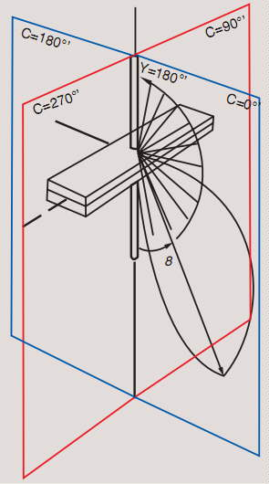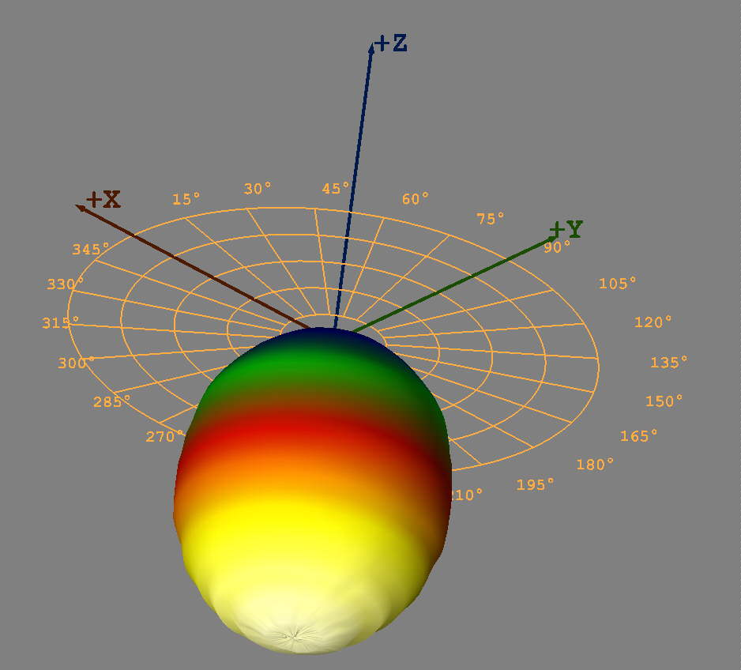
Luminaire light distribution of the 3D

TEST REPORT 2017-030-27.01.2017 | page 3 | all pages 4

Light distribution of luminaries are in tabular form
for conditional luminous flux 1000lm:

gm/C 0 15 30 45 60 75 90 105 120 135 150 165 180
0.0 402 402 402 402 401 401 399 401 401 402 402 402 402
2.5 401 400 399 399 399 399 400 399 399 399 399 400 401
5.0 400 402 402 402 401 400 399 400 401 402 402 402 400
7.5 395 395 395 395 393 393 394 393 393 395 395 395 395
10.0 393 392 391 391 392 392 392 392 392 391 391 392 393
12.5 376 375 375 376 378 379 378 379 378 376 375 375 376
15.0 375 375 377 378 379 379 377 379 379 378 377 375 375
17.5 362 362 362 363 364 365 367 365 364 363 362 362 362
20.0 357 356 356 357 358 359 361 359 358 357 356 356 357
22.5 345 345 345 345 346 347 348 347 346 345 345 345 345
25.0 336 335 336 337 338 340 340 340 338 337 336 335 336
27.5 322 321 320 320 320 323 326 323 320 320 320 321 322
30.0 306 306 307 308 311 313 315 313 311 308 307 306 306
32.5 297 296 297 298 299 301 301 301 299 298 297 296 297
35.0 281 280 281 282 284 286 288 286 284 282 281 280 281
37.5 267 266 266 267 271 274 275 274 271 267 266 266 267
40.0 251 251 251 252 255 258 260 258 255 252 251 251 251
42.5 235 234 234 236 238 240 242 240 238 236 234 234 235
45.0 221 222 223 224 226 228 229 228 226 224 223 222 221
47.5 206 206 207 208 211 213 215 213 211 208 207 206 206
50.0 146 195 196 197 199 202 203 202 199 197 196 195 146
52.5 183 183 184 186 188 191 192 191 188 186 184 183 183
55.0 172 173 173 175 177 179 181 179 177 175 173 173 172
57.5 159 158 159 161 163 165 166 165 163 161 159 158 159
60.0 142 142 143 144 146 147 149 147 146 144 143 142 142
62.5 126 127 127 129 130 132 134 132 130 129 127 127 126
65.0 114 114 114 115 117 118 119 118 117 115 114 114 114
67.5 98 98 99 100 101 102 103 102 101 100 99 98 98
70.0 85 85 86 87 88 90 91 90 88 87 86 85 85
72.5 74 74 75 76 76 78 79 78 76 76 75 74 74
75.0 57 57 58 58 59 60 60 60 59 58 58 57 57
77.5 45 45 46 46 46 47 47 47 46 46 46 45 45
80.0 35 36 36 36 37 37 37 37 37 36 36 36 35
82.5 25 25 26 26 26 26 26 26 26 26 26 25 25
85.0 16 16 17 17 17 17 17 17 17 17 17 16 16
87.5 7 8 8 8 8 8 8 8 8 8 8 8 7
90.0 2 2 3 3 2 2 5 2 2 3 3 2 2
92.5 2 2 2 2 2 1 1 1 2 2 2 2 2
95.0 2 2 2 2 2 1 1 1 2 2 2 2 2
Changing the light flux

TEST REPORT 2017-030-27.01.2017 | page 4 | all pages 4

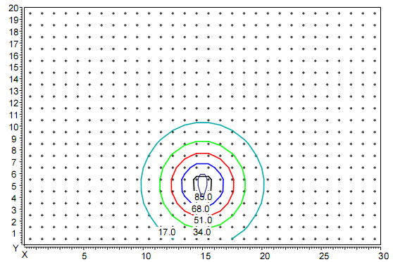
Distribution of illumination in height hanging lamp 5 м
Coordinates of the luminaire X=15m, Y=5m.

Applications:
Files with the EULUMDAT format. Light distribution is captured in γ-С planes with step 2.5^{о} in plane γ (от 0 ^{о} - 95 ^{о}) и 5^{о} in plane С (от 0 ^{о} - 360 ^{о}) accordance with EN 13032-1 p 4.2.3.
Files with the measured values
- 2017-030.ldt
(photometric data in a standard format),
Test results relate only to test samples.

Sofia 27.01.2017
Manager of Laboratory "Lighting":

/assoc. prof. d-r. Krasimir Velinov/

Manager:

/ prof. d-r. L. Totev/

